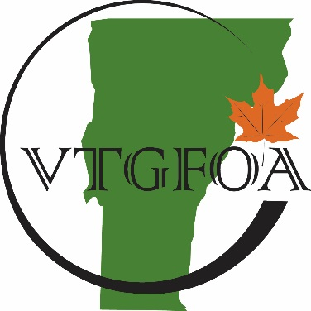

Vermont Government Finance

Officers Association
Annual Meeting Minutes
June 20, 2017

Members present: Angela Aldieri, Jeremiah Breer, Richard Brigham, Kathleen Brisson, Brenda Bryer, Colin Butler, Joann Davis, Melanie Dexter, Fred Duplessis, Susan Gage, Lyn Gelinas, William Hall, Colleen Hammond, Lisa Hart, Susan Johnson, Jennifer Kennelly, Cheryl Lindberg, Sarah Macy, Susan McNamara-Hill, Lauren Morrisseau, Jen Myers, John O’Connor, Wanda Oczechowski, Lynn Paradis, Kimberly Record, Christine Richter, Kaitlyn Sault, Jacolyn Savela, Christine Therrien, and John Weston

Nonmembers present: Raymond Austin, Carolyn Dawes, Michelle Dolloph, Gregory Maggard, Carrie Peters, Kim Seymour, and Marco Tallini

- President’s Welcome and Report
Sarah Macy opened the meeting at 11:49, welcoming members and attendees. Reminded attendees that only members may vote. Agenda change, item 5 and 6 will not be reported on, as board members were not able to make the meeting. Sarah reported that membership is increasing and trend appears to be continuing. VTGFOA members are automatically members of the New England States GFOA (NESGFOA).
We have an exciting couple of years ahead of us. Vermont will be hosting the NESGFOA conference in 2019 in Stowe. Also congratulated new Certified Public Finance Officer, Jeremiah Breer. This is an elite group of three in Vermont, including Bill Hall and Susan Chapman.

- Approval of Minutes
Minutes from the prior year, June 23, 2016 were reviewed, motion to approve was made and seconded. Acceptance of the minutes was approved.

- Treasurer’s Report
Presentation of May 2017 Financials
John O’Connor presented the financial reports through May. Noted on the Balance Sheet that we are setting aside funds for the NESGFOA conference, which are being reserved in the fund balance. The target fund balance is 25% of annual expenditures, and we are managing to maintain that as well as reserve funds for the conference. The annual Income Statement indicates a small deficit, but we budgeted for a deficit. We are happy to report that we were able to award almost $5,000 in scholarships this year for both VTGFOA trainings and the NESGFOA conference.

Proposed Budget 2018
John presented the budget for fiscal year ending 2018. Noted that we have increased the amounts in scholarships by eliminating mailing costs.

Motion was made and seconded to accept the financial reports and approve the budget. Motion approved.

- Education Committee Report
Bill Hall reported on the education committee. We have seen increased attendance at the trainings. The completed evaluations are very helpful in planning trainings and getting speakers. We offer 3 workshops annually in the fall, winter and the annual meeting in the summer. The goal is to offer full day workshops rather than the half day workshops we have offered in the past. Evaluations have indicated that attendees feel a full day would be more productive.

- Legislative Committee Report – Wendy Wilton
Eliminated from the agenda
- Membership Committee Report – Shelley Quinn
Eliminated from the agenda
- Board Nominations – Sarah Macy
Motion made to accept existing slate of board members: Sarah Macy, Wendy Wilton, Cheryl Lindberg, John O’Connor, Linda Peters, William Hall, Shelley Quinn, Robert Giroux, Aaron Frank and Susan Gage. Motion was seconded and passed.

- Other Business
Cheryl Lindberg reported on the NESGFOA, the board on which she, Bill Hall and Wendy Wilton sit as Vermont representatives. She reminded the group that membership in the VTGFOA was automatic membership in the NESGFOA. The annual conference for NESGFOA will be held in Maine this year, on September 17 – 20. In 2018 it will be held in Connecticut on September 16 – 19, and in 2019 we will be holding it in Stowe on September 8 – 11. Sponsorship is welcome for the annual NESGFOA conference that we will be hosting.

Reminder that CPE Credits are on the table to be picked up on the way to lunch or on the way out.

- Adjournment and Lunch
Motion was made to adjourn at 12:05 pm, seconded and passed.

Respectfully Submitted,

Susan Gage

